



**HOSTEL MESS MANAGEMENT SYSTEM**

Group member names:

Syeda Fakhira (22k-4413)

Tushar (22k-4260)

Aafreen (22k-4448)

Instructor: Sir Yasir Arfat

**Table of Contents**

MAIN IDEA 3

WORK DISTRIBUTION: 3

CODE DETAILS 3

CLASSES USED: 4

GOALS4

TOOLS AND TECHNOLOGIES4

LIBRARIES USED 4

FUNCTIONS: 5

Menu class: 5

Admin class: 5

User class: 5

Feedback class: 6

Mood determine class6

UML Diagram 7

Future Work 9

Problems Encountered9

**MAIN IDEA**

A comprehensive management system created to simplify and automate the hostel mess operations. It was created primarily to manage the hostel's mess facility's daily tasks—such as ordering food, creating menus, keeping track of inventory, charging customers, and giving feedback. In addition, there is a mood determination class which determines the mood of the customers and there are two kinds of customers. In this project one is students and another is faculty/staff. There is a 20% discount for the faculty customers and no discount for the students.

# **WORK DISTRIBUTION:**

Group work:

* Deciding the function and attributes for all the classes.
* Implementing classes in main.
* Debugging the code

| Name | Contribution |
| --- | --- |
| Syeda Fakhira Saghir | * Admin class * addmenu( ), edit menu( ), deletemenu( ) functions of the menu class |
| Tushar Khatri | * Menu class code * feedback class |
| Aafreen Mughal | * User class * files for menu class |

# **CODE DETAILS**

# **CLASSES USED:**

1. Class Menu
2. Class feedback
3. Class Admin
4. Class User
5. Class mood_determine

**GOALS**

The goals of this project are as follows:

**FUNCTIONAL GOALS:**

* To manage the hostel mess management system
* To allow the admin to control functionalities like registering users, add something to the menu menu, delete menu etc.
* To make the system of food ordering hustle free and faster for the Users.

**TECHNOLOGICAL GOALS:**

* System to be reliable.
* System being user-friendly.
* To balance business judgment, technology expertise, and technology investment.

**TOOLS AND TECHNOLOGIES**

IDE:

DEV C++ / VISUAL STUDIO

# LIBRARIES USED:

#include<iostream>

#include <cstdio>

#include<string.h>

#include<stdlib.h>

#include<time.h>

#include<string>

#include<fstream>

#include"Menu.h"

#include"FeedbackClass.h"

# **FUNCTIONS:**

# **Menu class:**

Read functions: All the data is being read from the text files and stoing into the array of breakfast, lunch, and dinner.

void read_breakfast ();

void read_lunch ();

void read_dinner ();

void read_Beverages ();

void read_Desserts ();

void read_Tandoor ();

void read_Raita ();

Display function: Displays the menu like the display breakfast function displays the item, quantity and price respectively.

void Display_Breakfast ();

void Display_Lunch();

void Display_Dinner();

void Display_Beverages();

void Display_Desserts();

void Display_Tandoor();

void Display_Raita ();

void Display_menu (); //Displays the whole menu

void editmenu (); //admin has the authorization to edit the menu like to add items

# **Admin class:**

bool login (string name, string pass, string id); //admin login

void Register (); //admin registers user

void viewusers (); //admin can view the info of user

void addmenu (); //admin can add menu items

void deletemenu () ; // admin can delete menu items

void editmenu (); //admin has the authorization to edit the menu like to add items.

void updateinfo (); //admin can update his or her information

static int totalearning (); //total earning of the restaurant

void viewtotalearning();

# **User class:**

void SignUp (); // if customer is not registered so he must register him/herself.

void login (); //if user is registered so he/she will use this function

void showmenu (); //user can view menu

void order (); // user will order items

void showbill();

Setters and getters:

void setname (string);

void setpassword (char, int);

string getname ();

char getpassword ();

# **Feedback class:**

void Feedback::input ();

int Feedback:: getRandomNumber ();

Attributes:

int id;

string good_feedback[size];

# **Mood determine class:**

Functions to generate random numbers:

int display_x();

int display_v();

int display_w();

Determining the mood of the user:

void determine();

Different random messages for the user after mood determined

Random output for yes/no questions

Switch case for other assistance options like outputting a motivational quote or recommending a book.

# **UML Diagram:**

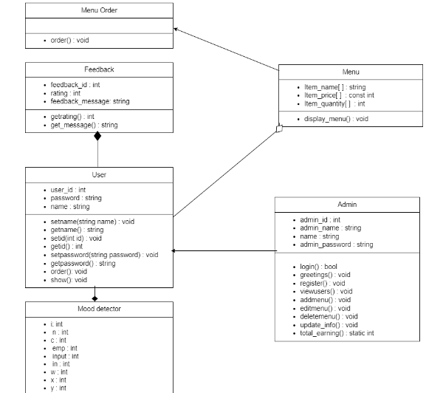

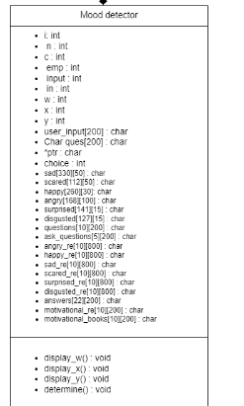

**FUTURE WORK**

The system can be enhanced by taking the system to the web server which will eliminate the limitation of the system to only PC users. It will be accessible to anyone at any time. Different organizations such a s schools and colleges can create their accounts on our website and use the management system. The basic structure of this system can also be reused in future works as the tools are modern and efficient.

The user interface can also be improved by deploying proper UI/UX developers but as for now, the system should fulfill the basic requirements.

**PROBLEMS ENCOUNTERED**

Figuring out the classes to be used as libraries was a bit challenging but it was super helpful once we figured that out.

We also had issues in creating functions in the user class as firstly we didn't use composition to access the member variables but that issue was also figured out and managed by us.

Another problem we faced was during the user input with spaces. We used getline(cin, input). However, at one point that too wasn’t working so we researched and found out that it was due to the memory jog up. So we used cin.ignore( ) to discard the number of characters in the stream up to the given delimiter.